Introduction
1. Introduction
This report is a working document being developed as part of the final project for the 2025 Higher Diploma in Computer Science at South East Technological University (SETU).
The project, provisionally titled SchemeThread, aims to explore the development of a software application to support independent interior designers and window-treatment specialists in recording and managing information gathered during site surveys.
The report will be developed and updated throughout the project. It will document the research, analysis, modelling and planning (RAMP) process, the investigation and evaluation of AI tools, the decisions made during development, and the implementation and testing of the final application.
As the project progresses, the scope and proposed solution may change in response to research findings, technical considerations and feedback.

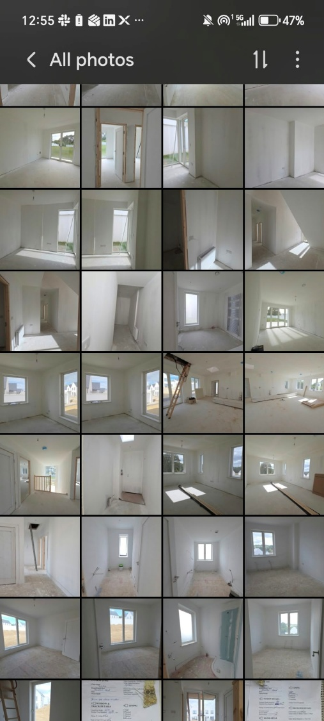
2. Background & Problem Definition
Figure 1: Sample of result of site survey before SchemeThread
Interior designers carrying out site surveys for window treatments must capture considerably more information than a window's width and height.
Measurements must be considered alongside room dimensions, finished floor levels, window operation, electrical fittings, obstructions, corner clearances and
other site conditions. Photographs and handwritten notes can also become difficult to associate with individual windows, particularly on unfinished building
sites where rooms can appear visually similar.
Missing or disconnected information may only become apparent after leaving the site, resulting in repeat visits, inaccurate specifications, incorrect fabric
quantities and incomplete workroom instructions. The workflow is further fragmented as information gathered on site is subsequently reused for treatment
specification, fabric calculations, production briefs and client documentation.

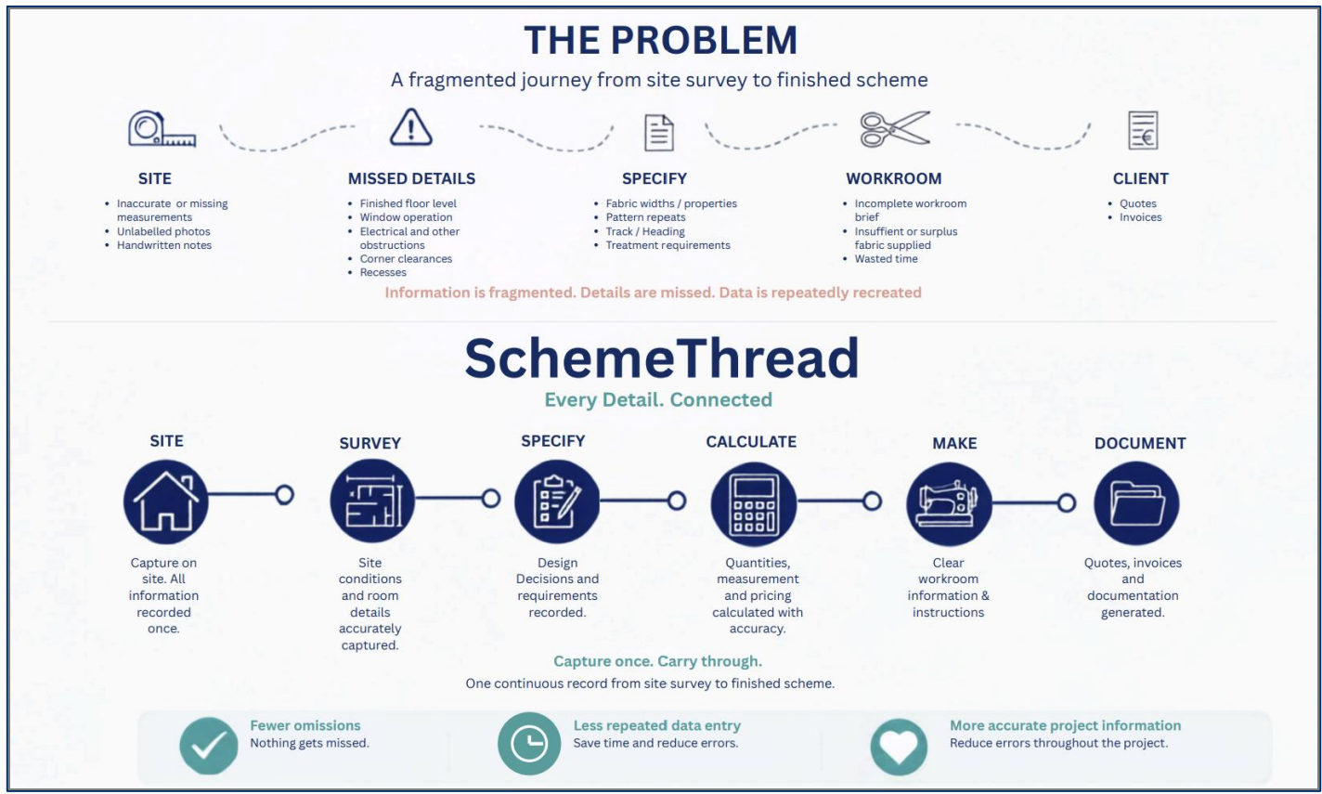
3. RAMP
3.1 Research
3.1.1 Existing complimentary and competing software
3.1.2 Open-Source Software integration
3.1.3 AI Tools

3.2 Analysis
Comparisons of research and analysis of impact for this solution

3.3 Modelling

3.4 Planning

4. AI USAGE & Critical Evaluation
4.1 AI Used
4.2 Critical Evaluation of AI Assistance

References
SAMPLE:
Author/Organisation (Year) Title of web page.
Available at: Web Address (Accessed: Date).

